



Analysis of National Learning Assessment Systems [ANLAS]

Report for

<Country name>

<Date>



Table of Contents

Acknowledgements 3

Abbreviations and acronyms 4

1 Introduction 5

1.1 The purpose of ANLAS 5

1.2 The ANLAS model 5

1.3 The ANLAS processes and tools 7

2 ANLAS in <country name> 9

2.1 Purpose of ANLAS in <country name> 9

2.2 Overview of the ANLAS implementation process 9

2.3 Limitations 10

3 Findings of ANLAS 11

3.1 Dimension 1: Context of the assessment system 11

3.2 Dimension 2A: Quality of large-scale assessment and examination 11

3.3 Dimension 2B: Quality of classroom assessment 12

3.4 Dimension 3: Coherence of the assessment system 12

4 Using the ANLAS findings 12

4.1 Dissemination strategy 12

4.2 Using the ANLAS findings 12

5 References 14

6 Appendices 15

Appendix 1: ANLAS findings and recommendations 15

Appendix 2: National team and steering committee 16

Appendix 3: Data sources for the analysis 17

[Detailed instructions for reporting the ANLAS findings and for using the report template are provided in the ANLAS Manual (see sections 4.5 and 4.6).]

Acknowledgements

The Analysis of National Learning Assessment Systems (ANLAS) was initiated by the Global Partnership for Education (GPE), and developed by the Australian Council *for* Educational Research (ACER). The ANLAS development process included three phases: 1) development of the ANLAS tools and processes (July 2018 to January 2019); 2) pilot implementation of ANLAS in three GPE partner countries Ethiopia, Mauritania[1] and Vietnam (January to August 2019); and 3) revision and refinement of ANLAS based on observations and experiences from the pilot implementations and external reviews of the ANLAS manual and tools (July to September 2019). The external reviews involved representatives from the GPE Secretariat and Country Support Team, World Bank, CONFEMEN/PASEC, UNESCO IIEP-Pole de Dakar, DFID, Porticus and UNICEF. The substantive contributions and cooperation across the organizations, piloting countries and individuals involved were essential for the ANLAS development process.

[Provide national acknowledgements in relation to the ANLAS implementation in the country.]

Abbreviations and acronyms

|  |  |
| --- | --- |
| ACER | Australian Council for Educational Research |
| A4L | Assessment for Learning initiative of the GPE |
| ANLAS | Analysis of National Learning Assessment Systems |
| CONFEMEN | Conférence des Ministres de l’Education des Etats et Gouvernements de la Francophonie (in English: Conference of Ministers of Education in French-Speaking Countries) |
| DFID | Department for International Development (United Kingdom) |
| ESP | Education Sector Plan |
| ESPIG | Education Sector Program Implementation Grant |
| GPE | Global Partnership for Education |
| IIEP | International Institute for Educational Planning |
| PASEC | Programme d’Analyse des Systèmes Educatifs de la CONFEMEN (in English: The Analysis Programme of the CONFEMEN Education Systems) |
| UNESCO | United Nations Educational, Scientific and Cultural Organization |
| UNICEF | United Nations Children’s Fund |

[Complete this table with the abbreviations and acronyms used in the ANLAS report. Add rows as needed.]

Introduction

The purpose of ANLAS

The *Analysis of National Learning Assessment Systems (ANLAS)* has been initiated by the Global Partnership for Education (GPE) as part of the Assessment for Learning (A4L) initiative to provide a resource for countries around the world to analyze and build effective and sustainable learning assessment systems.[2]

Learning assessments are increasingly used by education systems around the world to inform evidence-based policymaking and reform processes, and to improve teaching and learning practice.[3] At the global level the agenda around the Sustainable Development Goal for Education (SDG 4) [4] to ‘*ensure inclusive and equitable quality education and promote lifelong learning opportunities for all’* by 2030, has reinforced a focus on learning assessment to gain data on learning that allow to establish and monitor education quality and learning progress.

For the GPE, high quality learning assessment systems are a key element of effective and efficient education systems. Countries that apply for GPE Education Sector Program Implementation Grants (EPIGs) are therefore required to have a system in place to capture learning data and to monitor student learning outcomes. A time-bound plan to develop such a system is also acceptable.[5] To further strengthen the capacity of learning assessment systems in partner countries, and to promote a holistic measurement of learning and the development of tools for assessing 21st century skills, the GPE launched the Assessment for Learning (A4L) initiative in 2017.

ANLAS complements the A4L initiative by providing a resource that countries can use to systematically gather and analyze information about their national learning assessment system. The comprehensive analysis is qualitative in nature. It is implemented as a country-led, participative process that involves key stakeholders in the education system and the assessment system. The analysis process enables key stakeholders to collaboratively analyze the current learning assessment system and identify where improvements can be made. Those findings can then be used to develop a set of recommendations on how the system can be strengthened. Based on these recommendations, strategies can then be developed and implemented through the country’s education sector planning process.

The ANLAS model

The ANLAS model illustrated in Exhibit 1 provides the framework for the qualitative analysis of national learning assessment systems.

Exhibit 1: The ANLAS model[6]

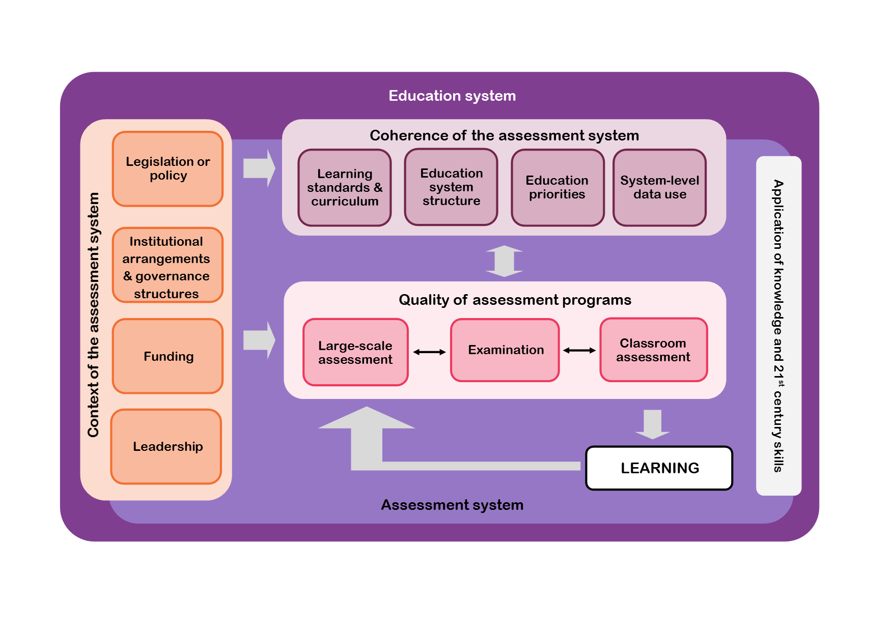

The ANLAS model focuses on three dimensions:

1. *Context of the assessment system,* at central as well as decentralized levels
2. *Quality of assessment programs:* large-scale assessment, examination and classroom assessment
3. *Coherence of the assessment system,* with regard to the wider education system and other elements within the assessment system.

An important element of ANLAS that is relevant to all three dimensions is the application of knowledge and 21st century skills. This element relates to the core purpose of learning assessment, *defined as the process of gathering and analyzing information on what students know, understand, can do and what progress they are making, in order to make informed decisions about the learning process.*[7] It is an increasing priority for countries around the world to assess the skills, knowledge, attributes and values that contribute to the holistic development of learners and that build the foundation for successful participation in life-long learning, occupational careers, society and life in general.[8] A focus has been on skills that are considered particularly important to succeed in today’s knowledge-based society in which innovation and technology are predominant. These skills are often referred to as 21st century skills.[9] Other terminology commonly used to describe this set of skills includes general capabilities, transversal competencies or cross-curricular competencies. Prominent examples of such skills are problem solving, critical thinking, creativity, communication, collaboration, and social-emotional skills (for example, intrapersonal, interpersonal, empathy).[10] Assessing the application of knowledge and demonstration of skills, such as students’ ability to solve problems, to think creatively and critically, to communicate their understanding, or to collaborate with others, is in contrast to approaches that solely focus on the demonstration of factual knowledge and routine procedures.[11] ANLAS is designed to support countries to examine the extent to which learning assessment focuses on the application of knowledge and demonstration of skills, and the extent to which 21st century skills are an integral part of their assessment system.

The three dimensions of the assessment system – context, quality of assessment programs, and coherence – and the cross-dimensional element of application of knowledge and 21st century skills are integrated to favor the use of assessment data in education policy and practice, with the ultimate aim to *improve learning*.[12]

The ANLAS processes and tools

ANLAS is conceptualized asa country-led, participative processthat enables key stakeholders in the education system and in the assessment system to collaboratively analyze the national learning assessment system, identify where improvements are required and make recommendations on how to strengthen the assessment system.

The ANLAS processes are implemented in three main phases:

1. *Initiation, training and planning phase:* This phase involves nominating a national team leader and establishing a national team that is comprised of senior representatives from relevant government and non-government units and agencies involved in learning assessment and in the education system. It is further recommended that the government establish a steering committee or other accountability body that provides guidance and oversight of ANLAS in the country. For ANLAS to be effective, it is essential that all national team members have a shared understanding of the purpose and implementation of ANLAS.

It is encouraged that ANLAS be conducted as part of the broader education sector analysis/ diagnostic and planning process in a country to ensure the findings feed into the development and implementation of improvement strategies through the national Education Sector Plan.

1. *Analysis phase:* The analysis of the national learning assessment system is the core element of ANLAS. The analysis is qualitative in nature, using document review and consultations with key stakeholders as the main methods. Within each of the ANLAS dimensions (context, quality of assessment programs, and coherence), several key areas are analyzed and evaluated, based on defined quality objectives. Three evaluation categories are provided to evaluate each key area against the defined quality objective:
2. *Achieved:* There are currently no improvements needed
3. *Partly achieved:* Improvements can be made
4. *Not achieved:* Improvements are required

The assessment programs to be included in the analysis, as well as the key stakeholders and documents to be consulted, are identified by the national team during the initiation, training and planning stage.

1. *Reporting and dissemination:* Reporting and dissemination are a key element of ANLAS to ensure the findings and recommendations made are further used in education sector planning processes. A dissemination strategy is developed to share and discuss the recommendations and key findings and to ensure broad application of the findings. A focus is thereby given to the development of improvement strategies that can be implemented through the country’s education sector planning process, or other policy processes.

The *ANLAS manual*[13] and *a set of tools* (in the form of Microsoft Word (2013) and Microsoft Excel (2013) templates) are provided to support the implementation process and to guide the analysis*.* Countries can adapt the tools to best fit the national context. This contextualization ensures that the identified areas and concrete recommendations for improvement are relevant and appropriate. The ANLAS manual and tools can be accessed through the GPE website.[14]

For more details about ANLAS see the *ANLAS Manual.[15]*

ANLAS in <country name>

[The purpose of this chapter is to document the main ANLAS implementation processes in the country.]

Purpose of ANLAS in <country name>

[Briefly describe the **motivation, purpose and goals** for undertaking ANLAS in the country. Include a brief description of the national learning assessment system, in particular the **assessment programs** included in the analysis.]

Overview of the ANLAS implementation process

[Briefly describe the implementation process of ANLAS in the country. Complete Exhibit 2 and relate to the three phases of the implementation process. Indicate the total duration of the ANLAS implementation process in the country.]

Exhibit 2: ANLAS implementation process in *<country name>*

|  |  |
| --- | --- |
| ANLAS phases | Dates and duration |
| Initiation, training and planning | [Indicate the date and duration of this phase.] |
| Analysis | [Indicate the date and duration of this phase.] |
| Reporting and dissemination | [Indicate the date and duration of this phase.] |
| Total duration of ANLAS implementation | [Indicate the total duration of the implementation.] |

Initiation, training and planning

[Provide an overview of how the initiation, training and planning was organized in the country and who was involved during this phase. Include a brief description of*:*

* The national team, including the number of team members, their organizations, and role in ANLAS. Refer to Exhibit 7 in Appendix 2 for more details about the steering committee.
* The stakeholder briefings, including the main stakeholder groups that participated, the number of briefings conducted, and what was achieved during the stakeholder briefings.
* The team training and planning, including the duration, how it was organized, the participation of the national team members, and the output of the training and planning, such as the identification of the assessment programs included in the analysis, the completed stakeholder and document mapping tables, and the implementation plan.]

Analysis

[Provide an overview of how the analysis was organized in the country and who was involved during this phase. Include a brief description of:

* How the national team organized the analysis and the responsibilities of the team members. For example, if sub-teams were established that were responsible for a particular ANLAS dimension or task.
* How the ANLAS dimensions were described, including the number and kinds of documents reviewed. Refer to Exhibit 8 Appendix 3 for the document mapping table.
* How the stakeholder consultations were conducted, including the number of consultations for each ANLAS dimension, the form of the consultations such as group or individual consultation, the key stakeholder groups consulted for each ANLAS dimension, and how the information was documented. Refer to Exhibit 9 in Appendix 3 for the stakeholder mapping table.
* How the information from multiple stakeholder consultations for each dimension was consolidated and then synthesized. Relate to the evaluation categories, the aspects for improvement and the recommendations made. Indicate if an overall consensus was reached.
* The involvement of the steering committee in the analysis phase. For example, support in sourcing documents, nomination of stakeholders for consultations, participation in stakeholder consultations, review of the analytical tables, and support in consolidating information from multiple stakeholder consultations.]

Reporting and dissemination

[Provide an overview of how reporting and dissemination were organized in the country and who was involved during this phase. Include a brief description of:

* How the ANLAS report was prepared, including the organization of the reporting process, and who was involved.
* The involvement of the steering committee. For example, through a review of the draft report, consultations about specific findings.
* How the dissemination strategy was developed and who was involved in this process.]

Limitations

[Briefly describe any limitations encountered during the ANLAS implementation. For example, whether all relevant documents could be accessed; whether key stakeholders were available for consultations; whether all dimensions and key areas could be adequately covered.]

Findings of ANLAS

[The purpose of this chapter is to present the ANLAS findings in an engaging way.

Start this section with an overview of the ANLAS findings. Insert Synthesis table 1: Overview of ANLAS findings under Exhibit 3.]

Exhibit 3: Overview of ANLAS findings

[Insert here the completed Synthesis table 1: Overview of ANLAS findings.]

[Provide a brief explanation of Exhibit 3 (for example: “Exhibit 3 provides an overview of the ANLAS findings, according to the consolidated evaluation category. For each ANLAS dimension the respective key area and quality objective is presented according to its consolidated evaluation category”.]

[Use the subheadings below (3.1 to 3.4) to provide a summary of the main findings for each ANLAS dimension. Refer to Exhibit 5 in Appendix 1 which should provide the completed Synthesis table 2: ANLAS findings and recommendations.

For each dimension:

* Provide a written summary of the findings for this dimension based on Exhibit 3 (Synthesis table 1): Indicate the key areas and the number of key areas that were achieved, partly achieved and not achieved.
* Discuss the detailed findings for this dimension based on Synthesis table 2. For each key area, highlight the main aspects for improvement and recommendations. Draw on the expertise in the national team and steering committee to reflect on the findings. This can include observations and experiences from the analysis phase, in particular concerning the evaluation of a key area against the quality objective, any identified connections and congruencies, as well as divergences and gaps between the quality objectives and the actual practices, and how these were addressed.]

Dimension 1: Context of the assessment system

Dimension 2A: Quality of large-scale assessment and examination

* Discuss the findings for each large-scale assessment and examination included in the analysis.
* Describe and highlight any commonalities or discrepancies that may appear across the different programs.

Dimension 2B: Quality of classroom assessment

* Discuss the findings for each level of school education that was analyzed separately.
* Describe and highlight any commonalities or discrepancies that may appear across the different levels.

Dimension 3: Coherence of the assessment system

Using the ANLAS findings

Dissemination strategy

[Briefly describe how the findings of ANLAS will be disseminated, in order to support broad application of the findings and recommendations. Relate to the completed ANLAS dissemination strategy (see ANLAS manual section 4.6.1)].

Provide a brief description of:

* The stakeholders/audience to be targeted
* The activity to disseminate the findings effectively (for example, a meeting or workshop)
* The dissemination products used as part of this activity (for example, the ANLAS report, key findings document or presentation)
* The timeline for each of the dissemination activities.

Using the ANLAS findings

[Describe how the ANLAS findings and recommendations will be used. Relate to the planned dissemination activities. In particular describe how the findings and recommendations will feed into national education sector planning processes or other policy processes.]

[Use and adapt Exhibit 4 below to illustrate how the ANLAS findings can be used in the national education sector planning process. List the years for the current ESP and the next iteration of the ESP. Indicate the stages that are most likely to consider the ANLAS findings (see section 4.1.1 in the ANLAS manual for more information.]

Exhibit 4: Education sector planning process

|  |  |
| --- | --- |
| Current Education Sector Plan (ESP) | [Years of the current ESP] |
| Next ESP | [Years of the next ESP] |
|  |  |
| Relevant education sector planning stages to consider ANLAS recommendations | Timing |
| [Education sector planning stage likely to consider the recommendations and findings of ANLAS] | [When this stage is planned for] |
| [Education sector planning stage likely to consider the recommendations and findings of ANLAS] | [When this stage is planned for] |
| [Education sector planning stage likely to consider the recommendations and findings of ANLAS] | [When this stage is planned for] |

[Describe at which stages and how the ANLAS findings are likely to be used in the national education sector planning process and/or other relevant policy processes. Consult with the national team members and the steering committee members who are familiar with the national education sector planning process to provide this information.]

References

[Add here any references used in this report using Chicago style referencing. Also, follow Chicago style for In-text references and add them as footnote. See section 4.6.2 in the ANLAS Manual for more information.]

Australian Council for Educational Research. "Analysis of National Learning Assessment Systems (ANLAS): Manual." Washington, DC: Global Partnership for Education, 2019.

Care, Esther, and Rebekah Luo. "Assessment of Transversal Competencies: Policy and Practice in the Asia-Pacific Region." Paris & Bangkok: UNESCO, 2016.

Cresswell, John C. "System-Level Assessment and Educational Policy." Melbourne: ACER, 2017.

Global Partnership for Education. "Global Partnership for Education." <https://www.globalpartnership.org/> 2019.

———. "Methodology Sheet for Global Partnership for Education Result Indicator 15." GPE, <https://www.globalpartnership.org/content/methodology-sheet-gpe-result-indicator-15>, 2018.

Inter-Agency and Expert Group on Sustainable Development Goal Indicators. "Report of the Inter-Agency and Expert Group on Sustainable Development Goal Indicators." 2016.

Masters, Geofferey N. "Reforming Education Assessment: Imperatives, Principles and Challenges." *Australian Education Review* 57 (2013).

Scoular, Claire, and Esther Care. "Teaching of Twenty-First Century Skills: Implications at System Levels in Australia ". In *Assessment and Teaching of 21st Century Skills: Research and Applications*, edited by Esther Care, Patrick Griffin and Mark Wilson, 145-62. Dordrecht: Springer Science and Business Media, 2017.

Turner, Ross. *Described Proficiency Scales and Learning Metrics. Assessment Gems No. 4*. Melbourne: ACER, 2014.

Appendices

Appendix 1: ANLAS findings and recommendations

Exhibit 5: ANLAS findings and recommendations

[Insert here the completed Synthesis Table 2.]

Appendix 2: National team and steering committee

Exhibit 6: National team members

|  |  |  |  |  |  |
| --- | --- | --- | --- | --- | --- |
| **Name** | **Title** | **Organization** | **Role in organization** | **Role in ANLAS** | **Stakeholder group** |
|  |  |  |  |  |  |
|  |  |  |  |  |  |
|  |  |  |  |  |  |
|  |  |  |  |  |  |
|  |  |  |  |  |  |
|  |  |  |  |  |  |
|  |  |  |  |  |  |
|  |  |  |  |  |  |

[Complete the table above based on the information in the stakeholder database. Add more rows as required.]

Exhibit 7: Steering committee members

|  |  |  |  |  |
| --- | --- | --- | --- | --- |
| **Name** | **Title** | **Organization** | **Role in organization** | **Stakeholder group** |
|  |  |  |  |  |
|  |  |  |  |  |
|  |  |  |  |  |
|  |  |  |  |  |
|  |  |  |  |  |
|  |  |  |  |  |
|  |  |  |  |  |
|  |  |  |  |  |

[Complete the table above based on the information in the stakeholder database. Add more rows as required

Appendix 3: Data sources for the analysis

Exhibit 8: Document mapping table

[Insert here the completed document mapping table.]

Exhibit 9: Stakeholder mapping table

[Insert here the completed stakeholder mapping table.]

1. In Mauritania ACER worked with CONFEMEN/PASEC to support the piloting of ANLAS.
2. Australian Council for Educational Research, "Analysis of National Learning Assessment Systems (ANLAS): Manual," 2019.
3. Cresswell, "System-Level Assessment and Educational Policy," 2017.
4. Inter-Agency and Expert Group on Sustainable Development Goal Indicators, "Report of the Inter-Agency and Expert Group on Sustainable Development Goal Indicators," 2016, 19.
5. "Methodology Sheet for Global Partnership for Education Result Indicator 15," GPE, 2018, https://www.globalpartnership.org/content/methodology-sheet-gpe-result-indicator-15.
6. Australian Council for Educational Research, 2019, 4.
7. Clarke, 2012; Masters, "Reforming Education Assessment: Imperatives, Principles and Challenges," *Australian Education Review* 57, 2013.
8. Global Partnership for Education, 2018.
9. Care and Luo, "Assessment of Transversal Competencies: Policy and Practice in the Asia-Pacific Region," 2016.
10. Scoular and Care, "Teaching of Twenty-First Century Skills: Implications at System Levels in Australia " 2017.
11. Turner, *Described Proficiency Scales and Learning Metrics. Assessment Gems No. 4*, 2014.
12. Australian Council for Educational Research, 2019.
13. Australian Council.for Educational Research, 2019.
14. "Global Partnership for Education," 2019, https://www.globalpartnership.org/
15. Australian Council for Educational Research, 2019.